Deerwalk Institute Of Technology
Internet Technology

Submitted By: Submitted To:
Name: Sagar Giri Sudhir Maharjan
Roll No. 205

Date: July 1st 2016
FTP
a) FTP server configuration and installation.
→ FTP stands for File Transfer Protocol. It is used to transfer file between machines in the Internet. It listens to port 20 and port 21. Port no 20 is for Data Connection and port no 21 is for Data Transfer.

Some FTP applications are:
- Pure ftp server
- ProFtp server
- tftpd pxe boot
- Cisco ios trasfer etc
- Vsftpd (Very Secure FTP server)

Required Package in linux system are:
- Vsftpd for server
- ftp for client

Configuration:

See the port is available or not using command:
$ netstat -ntlup | grep 21
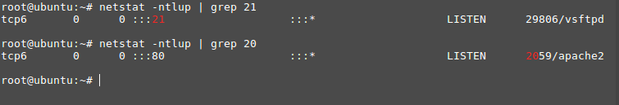

0.0.0.0 indicates it is bound to all available IP address in a machine
192.168.0.10
192.168.0.11
192.168.0.12

Configuration files is: /etc/vsftpd.conf

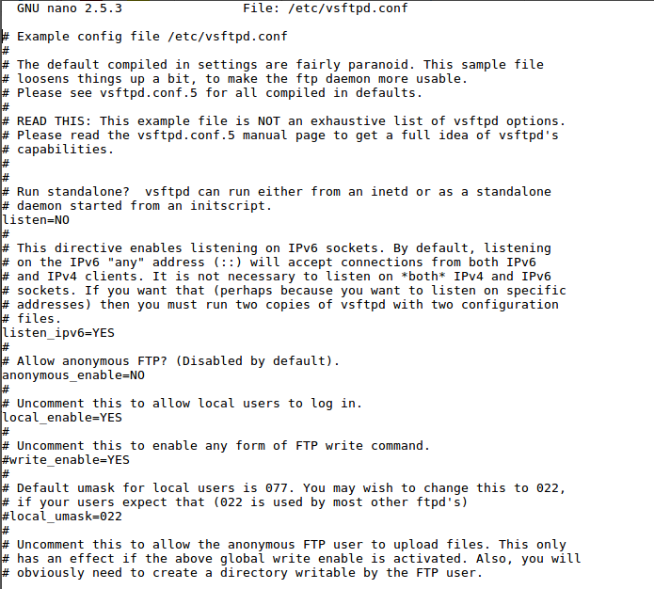

Configuration parameters
anonymous_enable=NO
i.e username: FTP which is created default during installation.

If we wan to enable anonymous user to upload files in ftp server we need to enable
anon_upload_enable=YES

local_enable=YES
This will allow Linux user to use ftp service.

allow_writeable_chroot=YES
This is tell the Linux user to use FTP service in chrooted directory.

ftpd_banner=Welcome to My FTP service.
Use custom FTP banner.

To deny any user to FTP server put user-name in /etc/ftpusers

We can start client using $ ftp command:
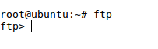

We can execute Linux command in FTP client by putting ! at the beginning of the command.

eg
ftp>!clear
ftp>!ls

To explicitly allow user put following parameter in the in /etc/vsftpd.conf

userlist_enable=YES
userlist_file=/etc/vsftpd.userlist
userlist_deny=NO

Login to FTP server:
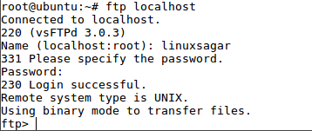

FTP Commands:
- put → put single file or upload single file to FTP server
- get → download single file from FTP server to current Linux location
- mput → uploads multiple file to FTP server
- mget → download multiple file from FTP server
- ls → list files and directory in FTP server
- dir → same as ls
- cd → change directory in ftp server

